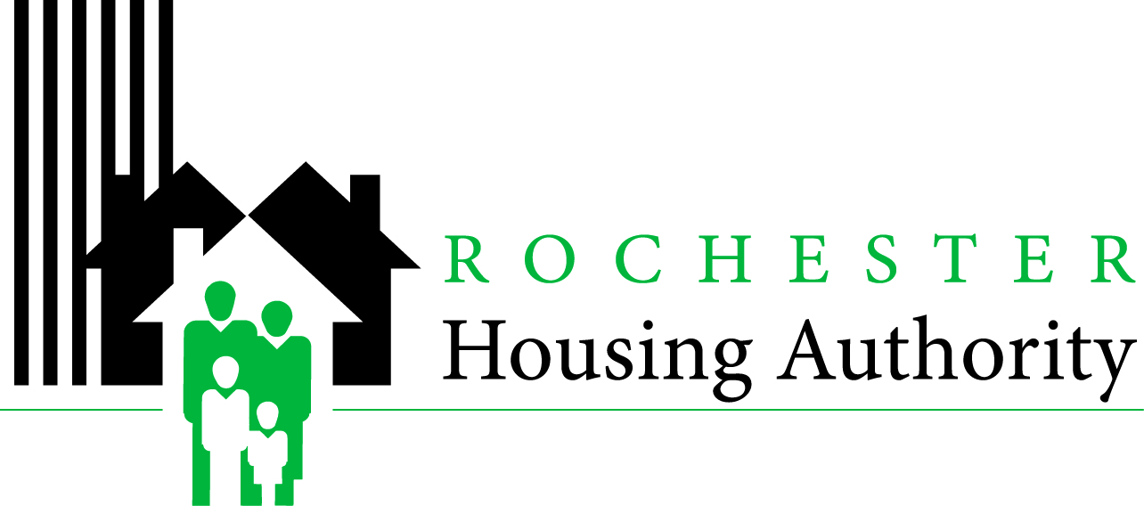
Parkside
Project Based Voucher Housing Application

To apply for subsidized housing at Parkside complete all sections of this application.

First Name: _______________________ Middle Initial: ____ Last Name: _________________________
Street Address: ____________________________ City: _________________ State: ____ Zip: _________
Home Phone: (______) _________ - ____________ Alternate Phone: (______) _________ - ____________
Please enter the family’s TOTAL ANNUAL INCOME. If None, enter 0: $__________________
Please indicate if your family’s INCOME SOURCE is any of the following:
Wages Social Security SSI/SSD DHS Other Welfare Other (Child Support, etc.)
Gender: M F Date of Birth: _____/______/_____ Social Security Number: ______-______-______
Race (optional): White Black/African American American Indian Asian Pacific/Islander
Ethnicity (optional): Hispanic Non-Hispanic
First Name | Middle Initial | Last Name | Social Security Number | Relationship to Applicant | Sex  M/F | Date of Birth | Disabled? Yes or No | Pregnant?
 |  |  |  | Head of Household
Have you ever served in the Military? Yes No
Are you currently homeless? Yes No
Does anyone living in your household require a unit with the following accommodations?
Wheelchair Accessibility Hearing Impaired Accessibility Visually Impaired Accessibility
Is there anyone in the household subject to a lifetime state sex offender registration program in any state?
(Failure to answer this question may jeopardize the approval of this application.) Yes No

Signature Date
Return to:
Parkside Apartments
Attn: Central Zone 86 Vienna St. 14605
If you or anyone in our family is a person with disabilities, and you require a specific accommodation in order to fully utilize our programs or services, please submit your request in writing to Rochester Housing Authority attention: PBV Waiting List at 675 West Main St Rochester NY 14611.
Victims of domestic violence, dating violence, or stalking may have protections provided by the Violence Against Women’s Act, or if you or anyone in your family is a person with disabilities, and you require a specific accommodation in order to fully utilize our programs and services, please contact the Housing Authority immediately
Rochester Housing Authority, 675 West Main Street, Rochester, NY 14611

